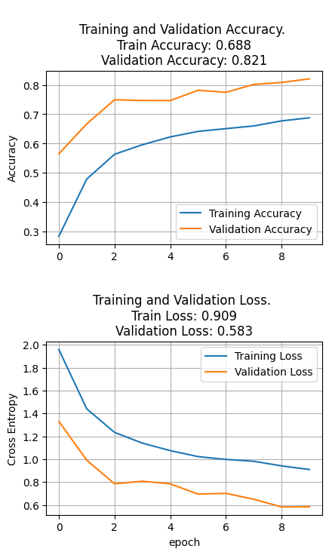

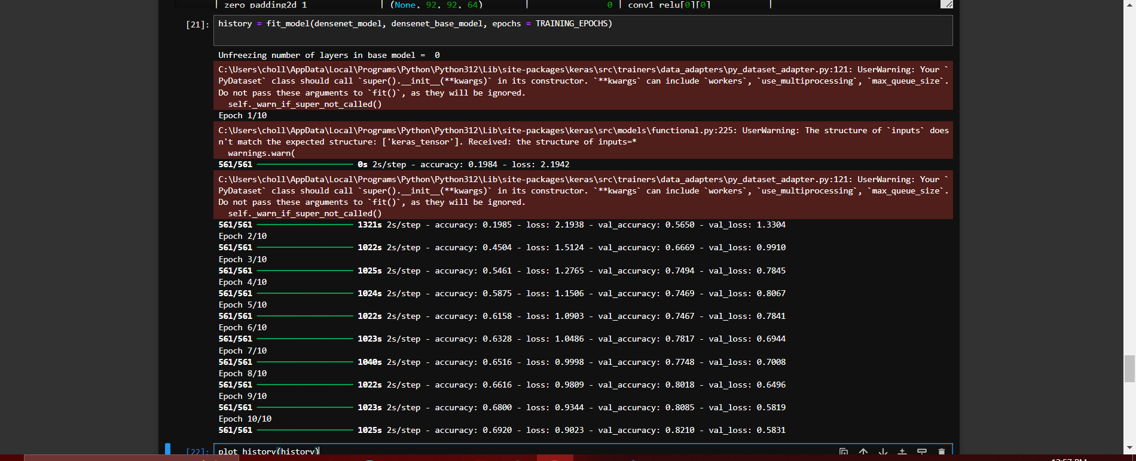

Precision (Micro): 0.8085

Recall (Micro): 0.8085

F1 Score (Micro): 0.8085

Class-wise Precision:

c0: 0.8153

c1: 0.8246

c2: 0.7200

c3: 0.9692

c4: 0.7262

c5: 0.9264

c6: 0.8306

c7: 0.9025

c8: 0.7909

c9: 0.6891

Class-wise Recall:

c0: 0.7149

c1: 0.8180

c2: 0.9375

c3: 0.7699

c4: 0.9506

c5: 0.7833

c6: 0.7724

c7: 0.9576

c8: 0.5333

c9: 0.8304

**Total params:** 7,177,610 (27.38 MB)

**Trainable params:** 7,093,962 (27.06 MB)

**Non-trainable params:** 83,648 (326.75 KB)

Freeze 2

